- Veera Signature Herbal Hair Oil
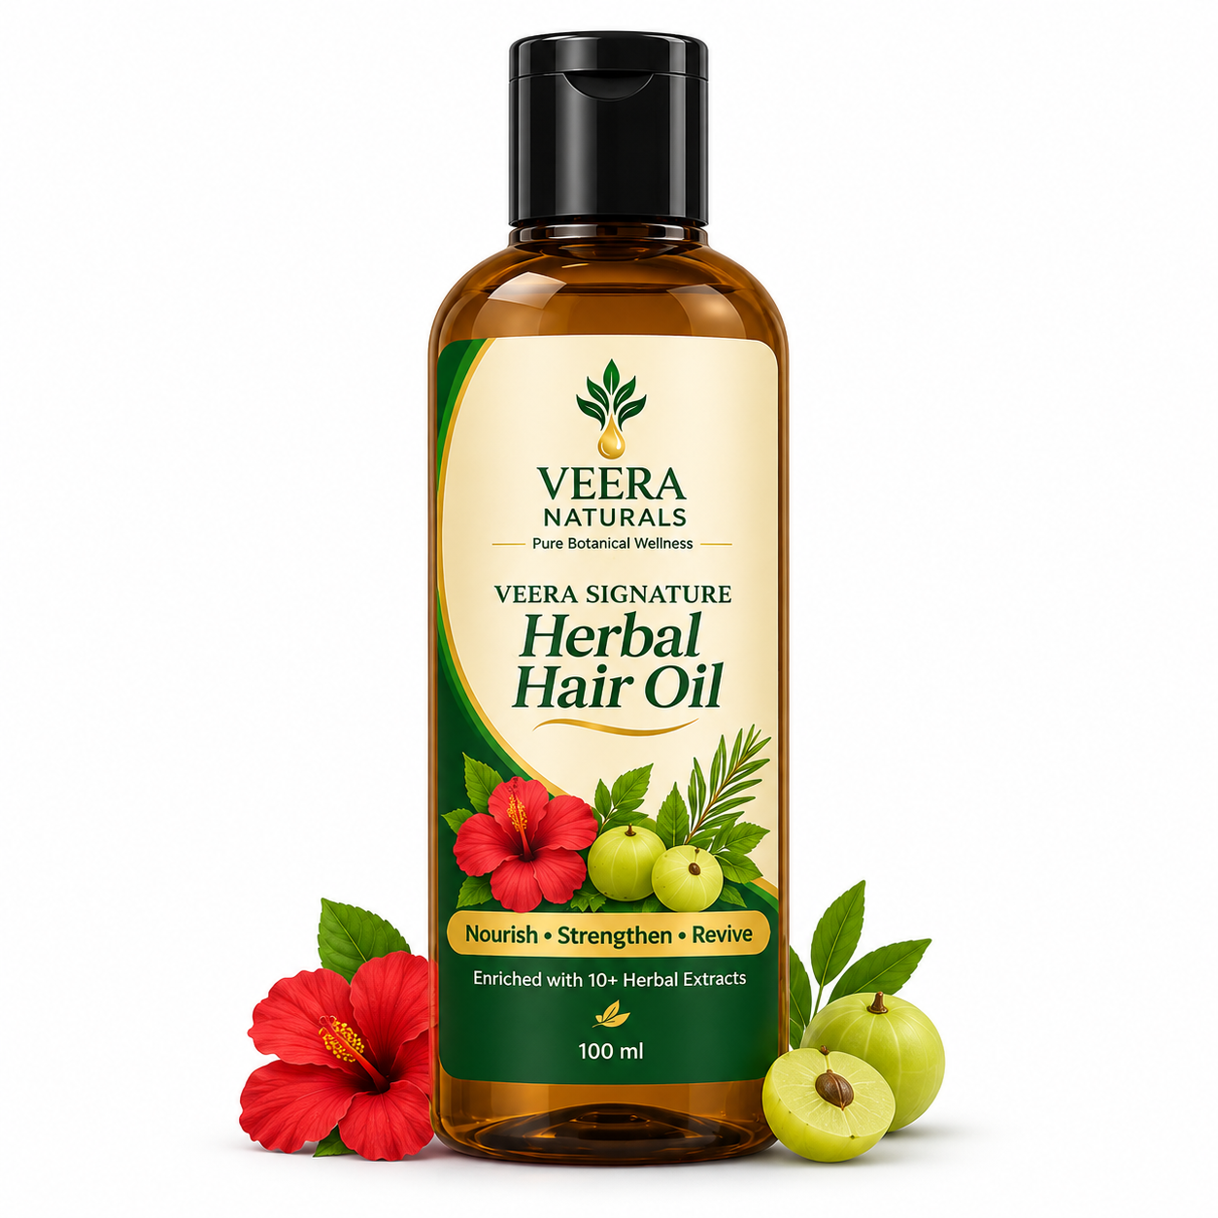
- Veera Pure Steam-Distilled Rose Water
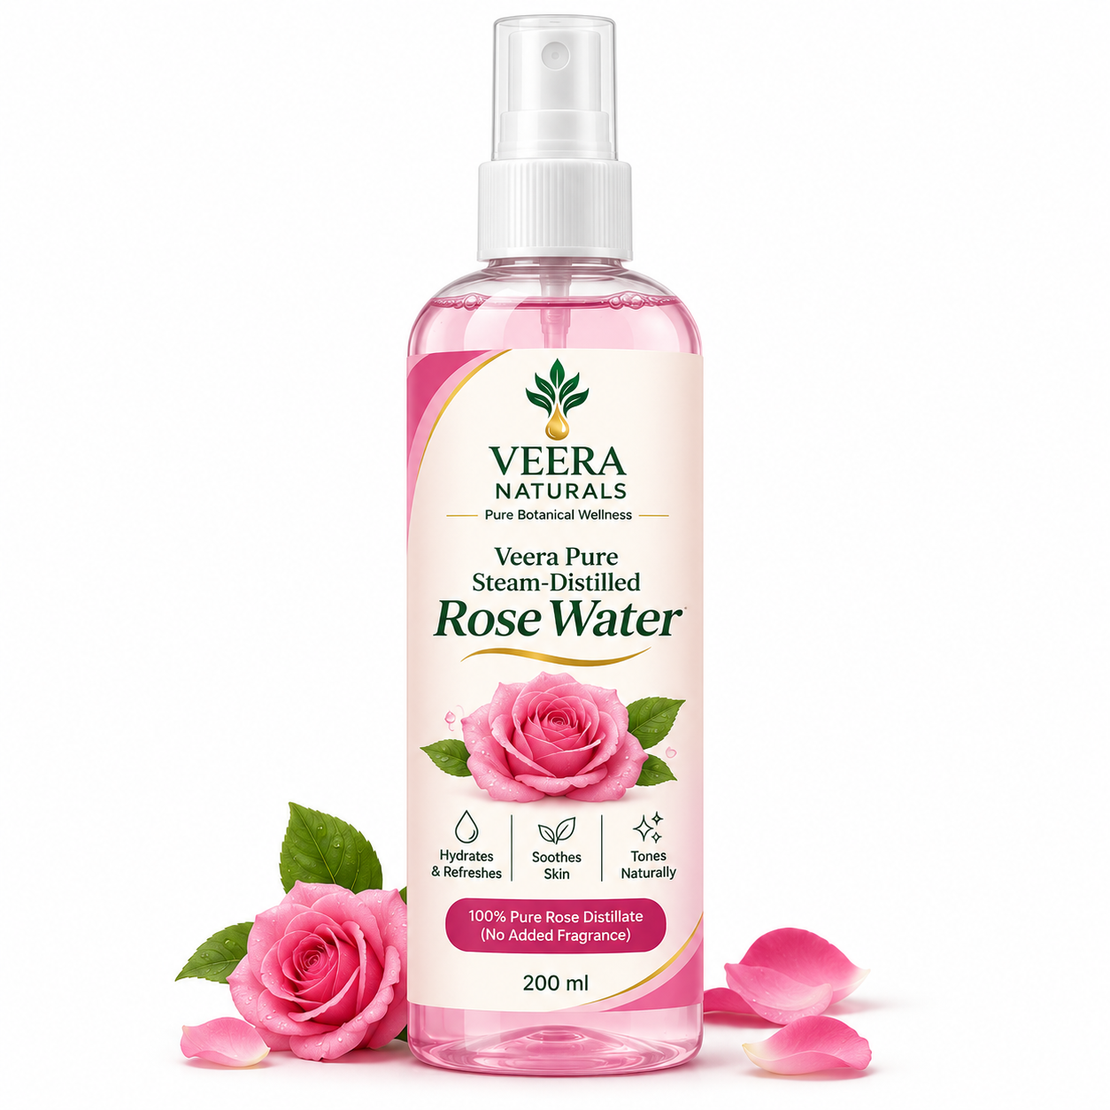
- Veera Golden Kumkumadi Glow Serum
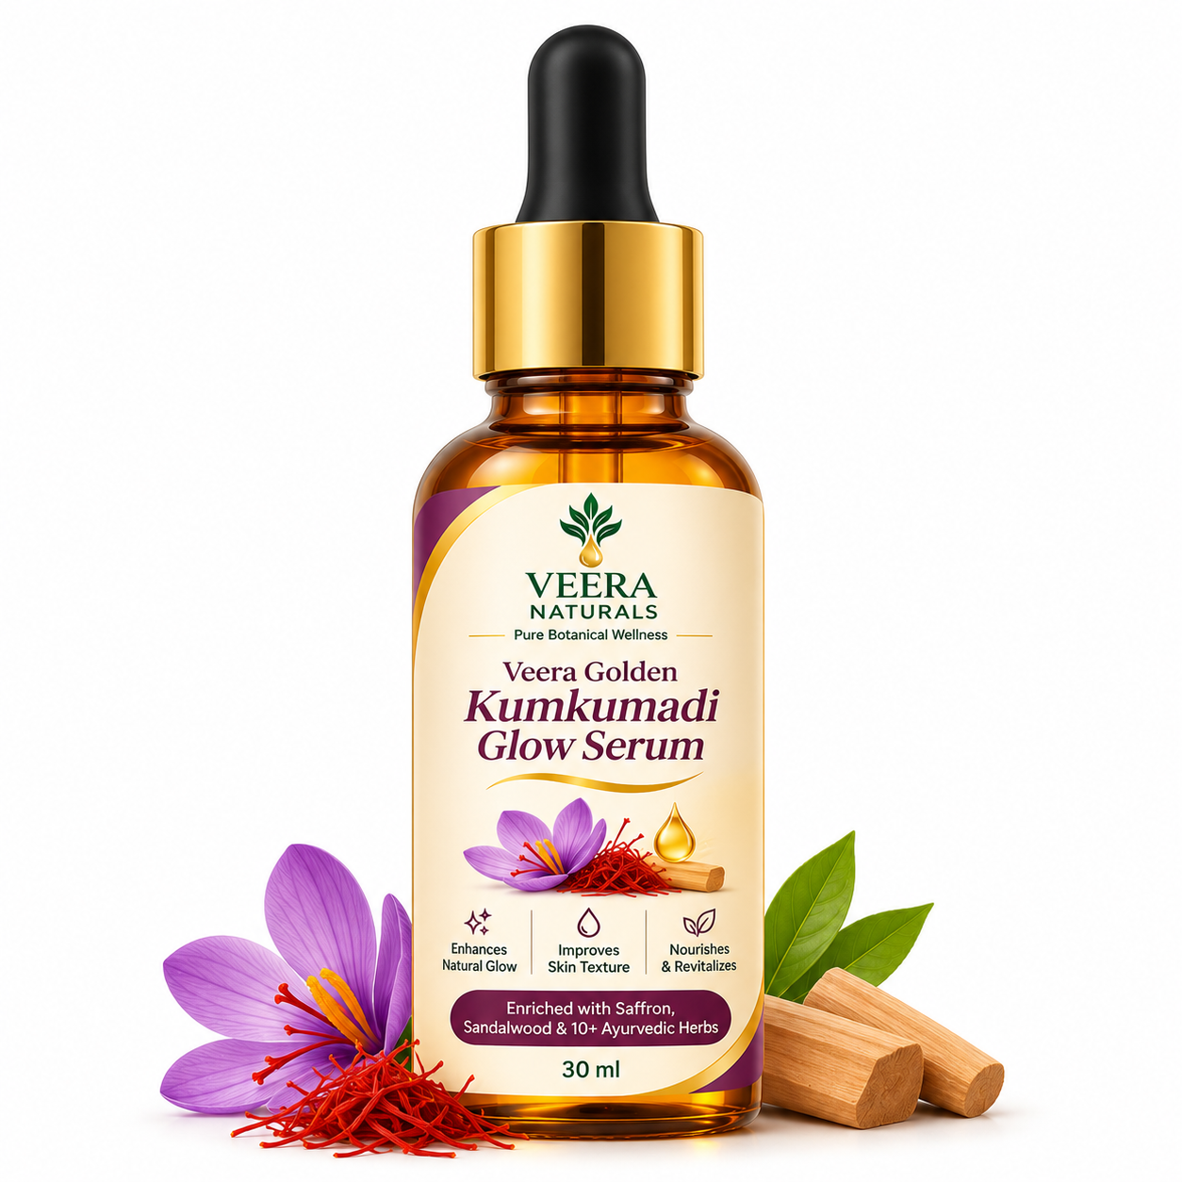
- Veera Pure Himalayan Lavender Essential Oil
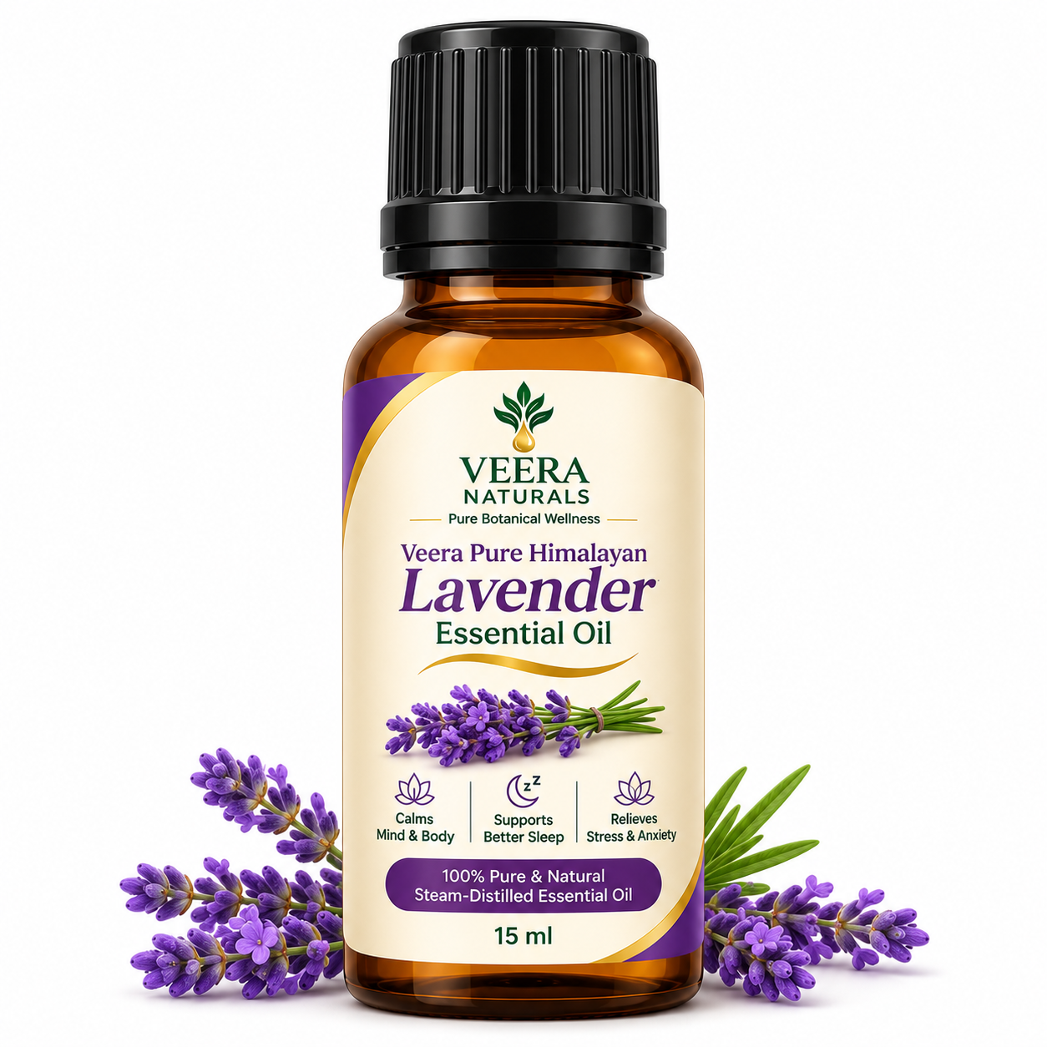
- Veera Wild Hibiscus & Shikakai Shampoo Bar
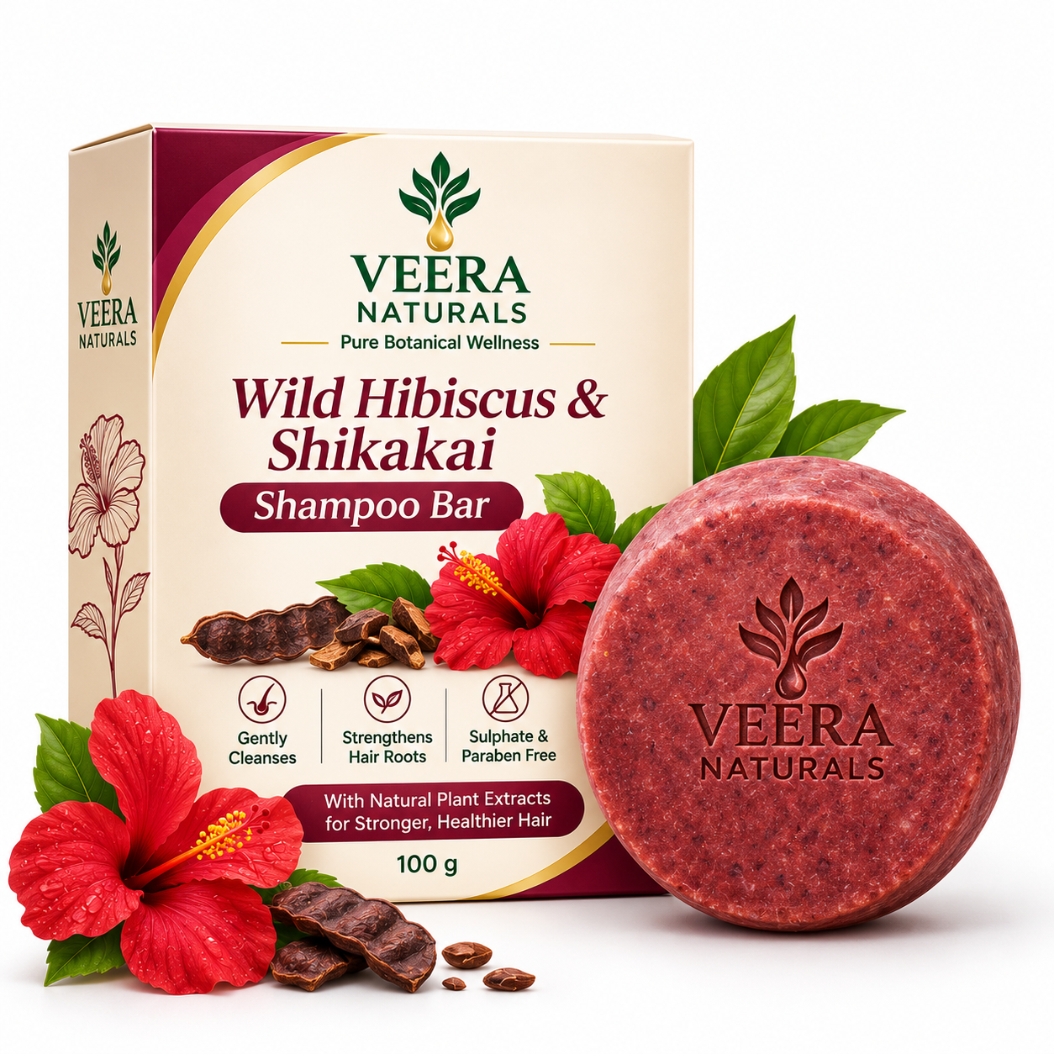
- Veera Shea & Cocoa Deep Nourish Body Butter
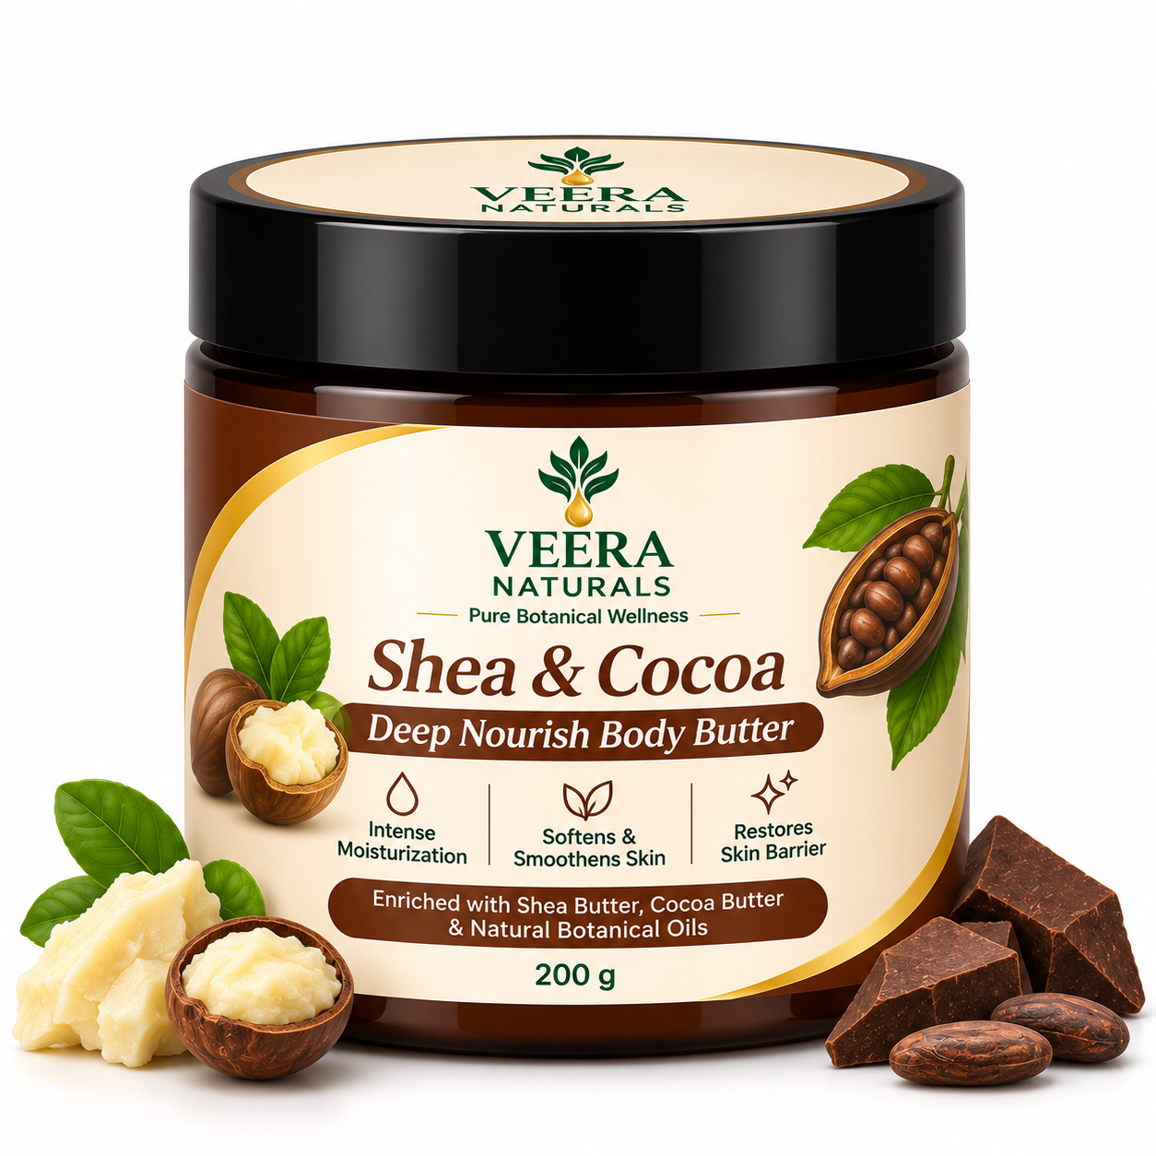
- Veera Neem & Tea Tree Purifying Face Cleanser
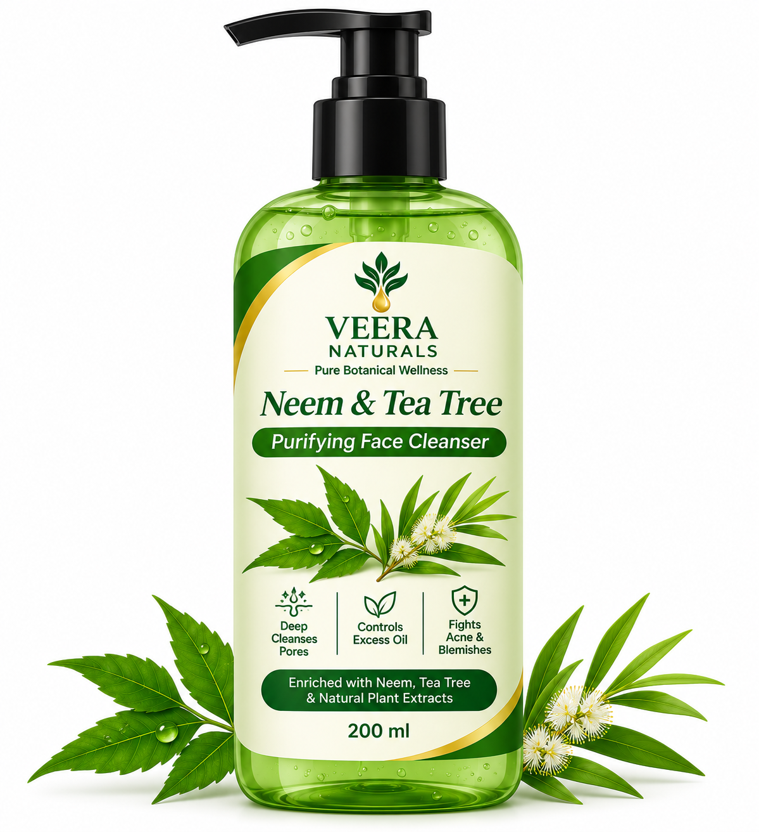
- Veera Arabica Espresso & Coconut Exfoliating Scrub
- Veera Sweet Orange Mood Booster Essential Oil
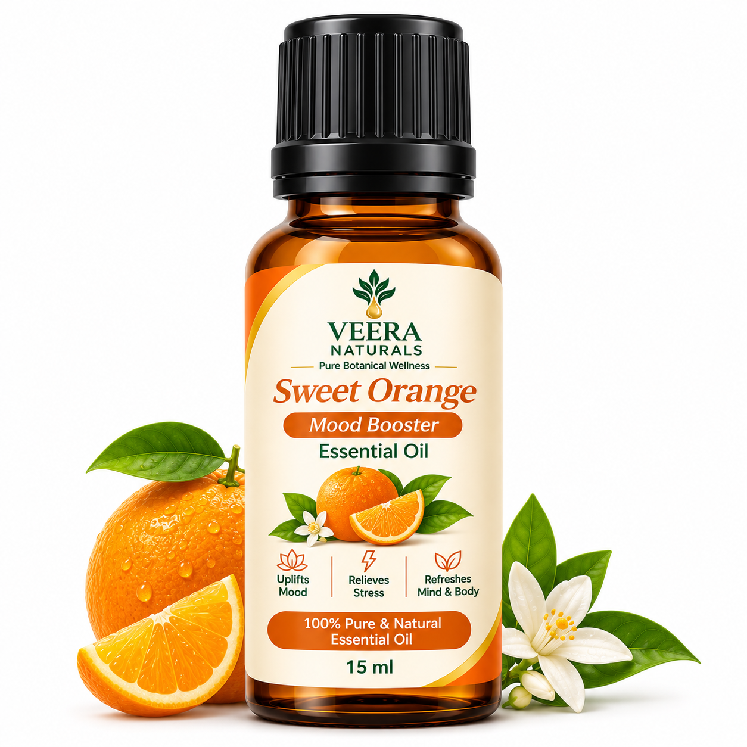

- Veera Kashmiri Walnut Glow Scrub
